WorkHorse XL
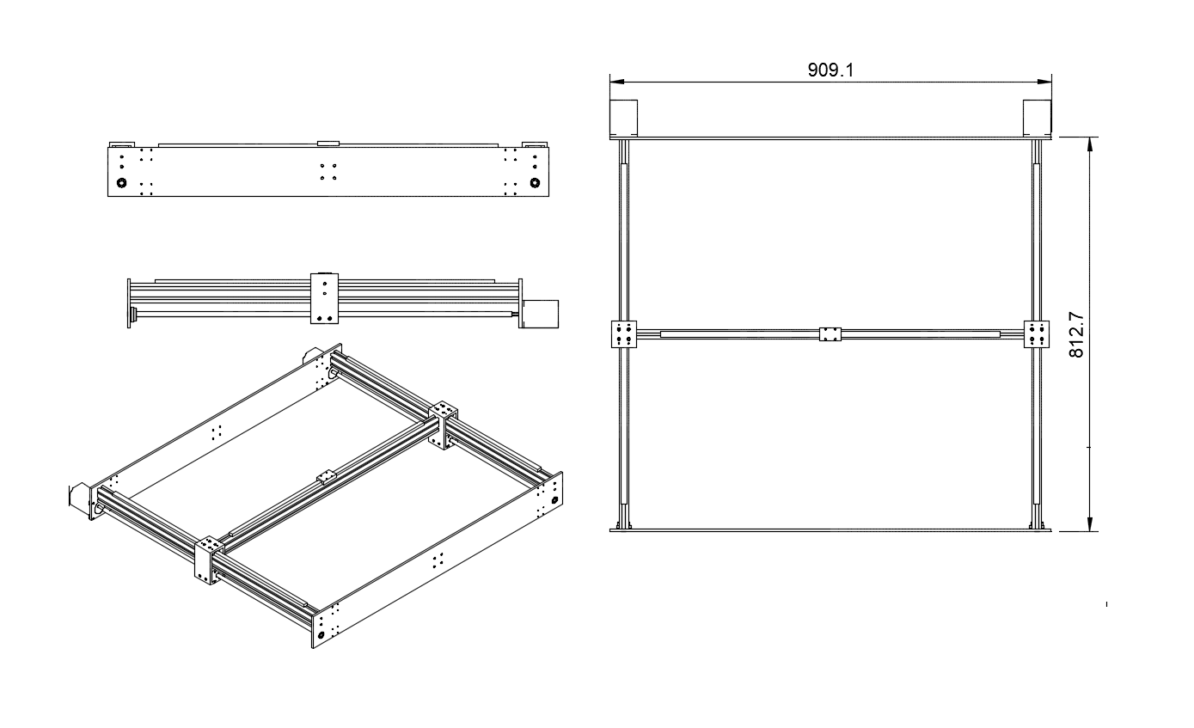

The Workhorse XL is a larger version of the Workhorse Printer. Although the original design is modular and made to be expanded upon the frame, extrusions must be beefed up to maintain rigidity.
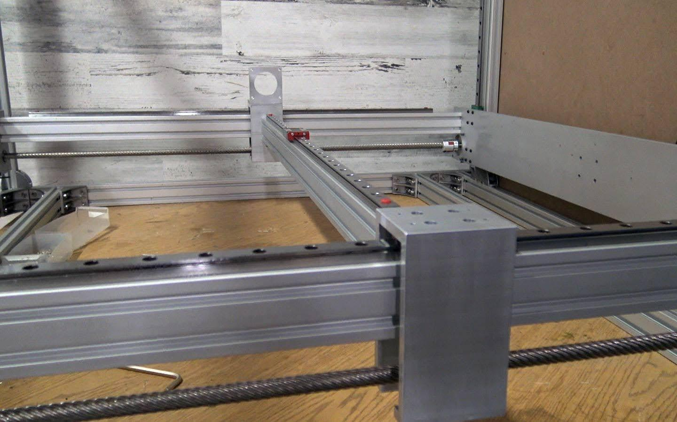

Most 3d printers use belt driven motion in the x and y axis to increase print speed but loses quality when more weight is applied to the gantry or carriage. The lead screw used on the Workhorse has a high helix pitch with multiple threads to allow increased print speeds while maintaining the quality provided from lead screw and ball screw motion.

The robust and rigid system is particularly useful in applications that add more weight to the gantry or carriage. Materials such as clay, chocolate, plastic pellet extrusion or other foods can increase weight that is moved around which results in decreased quality or print speeds.

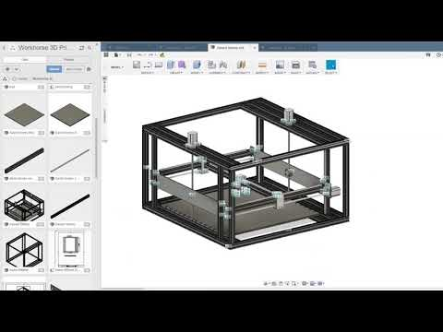

WorkHorse XL
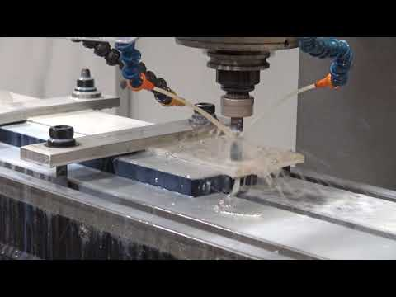
Workhorse XL Aluminum Gantry Plates

WorkHorse XL Files
Download Files https://www.thingiverse.com/thing:3069597

Electronics
On the WorkHorse XL we recommend the Duet 3 Mainboard electronics by Duet3D instead of the Duet 2 Wifi.

BOM

Related Content
3D Distributed
3D Printers
Nema Motor Mounts
WorkHorse 3D Printer
SolidCore CoreXY 3D Printer
Duet3D
Houston
CoreXY
CAD/CAM
Midwest RepRap Festival
Belt Frequency And Tensioning
Best CoreXY 3D Printer 2020
E3D ToolChanger CAD Files
Houston Maker Faire
Large Scale 3D Printers
Machine Shop
MRRF 2019
Prusa XL CoreXY
RailCore 3D Printer
Rapid Event + TCT
WorkHorse 3D Printer
WorkHorse XL

3D Distributed
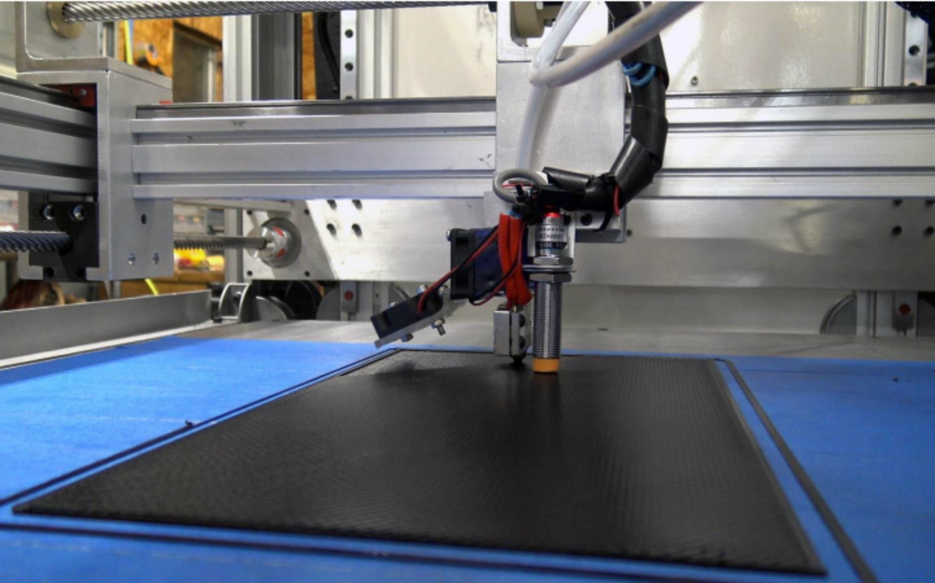
DIY 3D Printers
3D Printer Parts
3D Printer Kits
Large Scale 3D Printers
CoreXY
Midwest RepRap Festival
All Metal 3D Printer Parts
12601 Bowles Rd. Conroe, TX 77304

